**Industrial Internship Report on**

**“Quiz Game”**

**Prepared by**

**Bhyrappagari Bhavana**

|  |
| --- |
| *Executive Summary* |
| This report provides details of the Industrial Internship provided by upskill Campus and The IoT Academy in collaboration with Industrial Partner UniConverge Technologies Pvt Ltd (UCT).  This internship was focused on a project/problem statement provided by UCT. We had to finish the project including the report in 6 weeks’ time.  My project was Quiz Game  This internship gave me a very good opportunity to get exposure to Industrial problems and design/implement solutions for that. It was an overall great experience to have this internship. |

**TABLE OF CONTENTS**

**1. Preface 3**

**2. Introduction 4**

2.1. About UniConverge Technologies Pvt Ltd 4

2.2. About upskill Campus (USC) 8

2.3. The IoT Academy 10

2.4. Objectives of this Internship program 10

2.5. Glossary 10

**3. Problem Statement 11**

**4. Existing and Proposed solution 12**

4.1. Code submission (Github link) 12

4.2. Report submission (Github link) 12

**5. Proposed Design/ Model 13**

5.1. Interface 13

**6. Performance Test** 14

**7. My learnings 15**

**8. Future work scope 16**

# Preface

**Why do we need an Internship ?**

In today's highly competitive job market, securing a successful career requires more than just academic qualifications. Employers increasingly seek candidates with practical experience and a deep understanding of the industry. Internships play a crucial role in bridging the gap between academic learning and professional practice.

**Brief Introduction about my project:**

This project aims to build a quiz game using Python. The scope of this project involves designing a user interface to display questions from a csv file and collect user answers along with their name, implementing a csv file system to store quiz data, and developing a scoring algorithm to track the user's progress and calculate their final score and display the leaderboard to other users as well.

I'm glad that Upskill Campus and UniConverge Technologies Pvt. Ltd. are providing this Industrial Internship, this Internship will be a great addition to my career.

How Program was planned

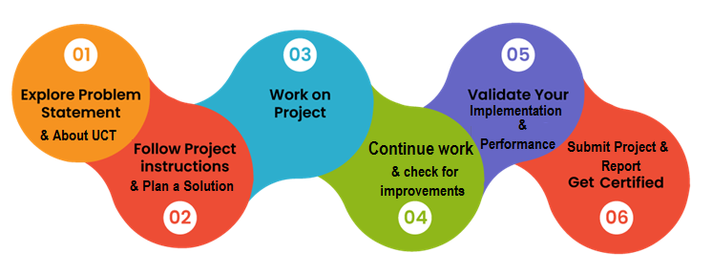

I would like to express my heartfelt gratitude to Upskill Campus and UniConverge Technologies Pvt. Ltd. for providing me with the opportunity to participate in this industrial internship. It has been an invaluable addition to my career development, allowing me to acquire new knowledge and skills. I am truly thankful for providing me this opportunity.

# Introduction

## About UniConverge Technologies Pvt Ltd

A company established in 2013 and working in Digital Transformation domain and providing Industrial solutions with prime focus on sustainability and RoI.

For developing its products and solutions it is leveraging various**Cutting Edge Technologies e.g. Internet of Things (IoT), Cyber Security, Cloud computing (AWS, Azure), Machine Learning, Communication Technologies (4G/5G/LoRaWAN), Java Full Stack, Python, Front end**etc.



1. **UCT IoT Platform (****)**

**UCT Insight** is an IOT platform designed for quick deployment of IOT applications on the same time providing valuable “insight” for your process/business. It has been built in Java for backend and ReactJS for Front end. It has support for MySQL and various NoSql Databases.

* It enables device connectivity via industry standard IoT protocols - MQTT, CoAP, HTTP, Modbus TCP, OPC UA
* It supports both cloud and on-premises deployments.

It has features to  
• Build Your own dashboard  
• Analytics and Reporting  
• Alert and Notification  
• Integration with third party application(Power BI, SAP, ERP)  
• Rule Engine

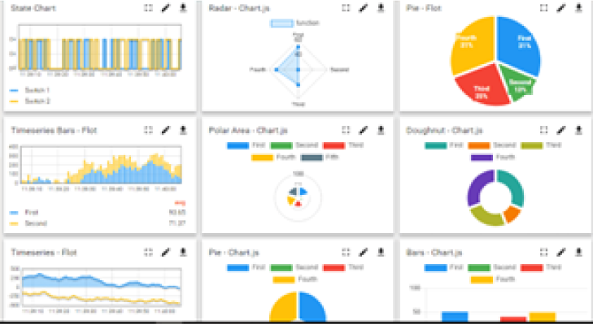 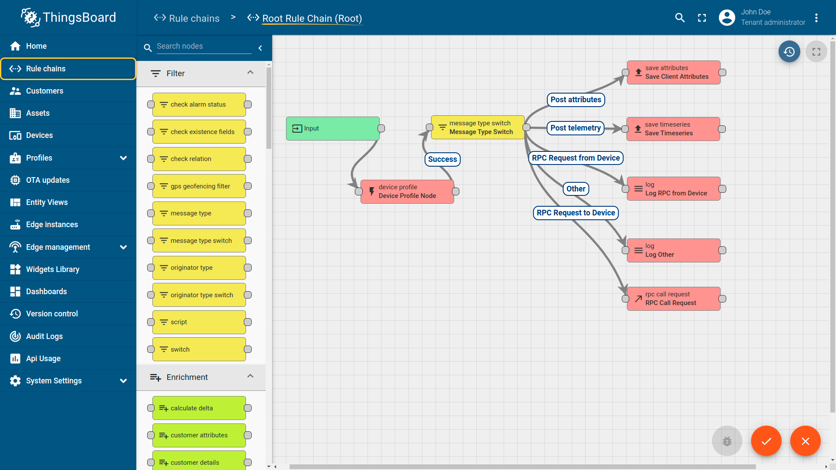

1. **Smart Factory Platform (****)**

Factory watch is a platform for smart factory needs.

It provides Users/ Factory

* With a scalable solution for their Production and asset monitoring
* OEE and predictive maintenance solution scaling up to digital twin for your assets.
* To unleash the true potential of the data that their machines are generating and helps to identify the KPIs and also improve them.
* A modular architecture that allows users to choose the service that they what to start and then can scale to more complex solutions as per their demands.

Its unique SaaS model helps users to save time, cost and money.

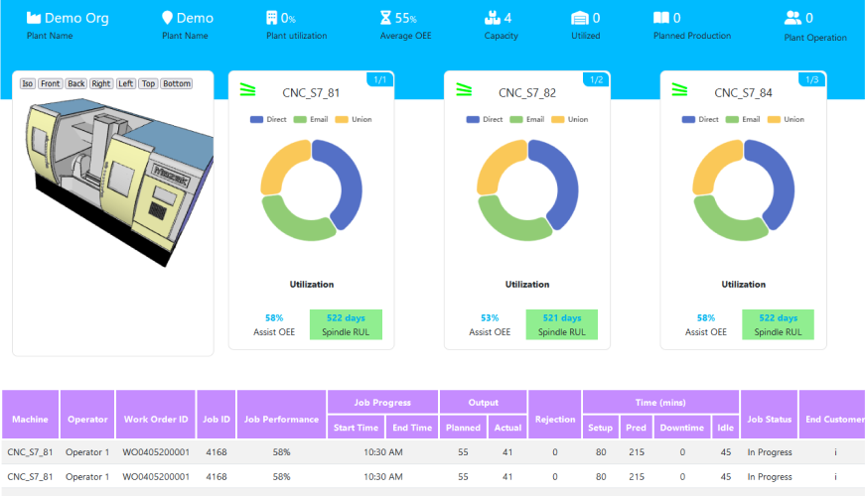 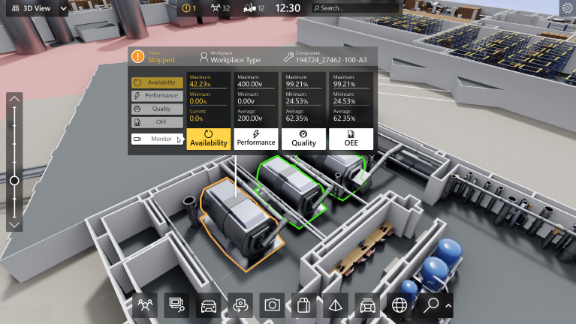

1.  based Solution

UCT is one of the early adopters of LoRAWAN technology and providing solution in Agritech, Smart cities, Industrial Monitoring, Smart Street Light, Smart Water/ Gas/ Electricity metering solutions etc.

1. Predictive Maintenance

UCT is providing Industrial Machine health monitoring and Predictive maintenance solution leveraging Embedded system, Industrial IoT and Machine Learning Technologies by finding Remaining useful life time of various Machines used in production process.

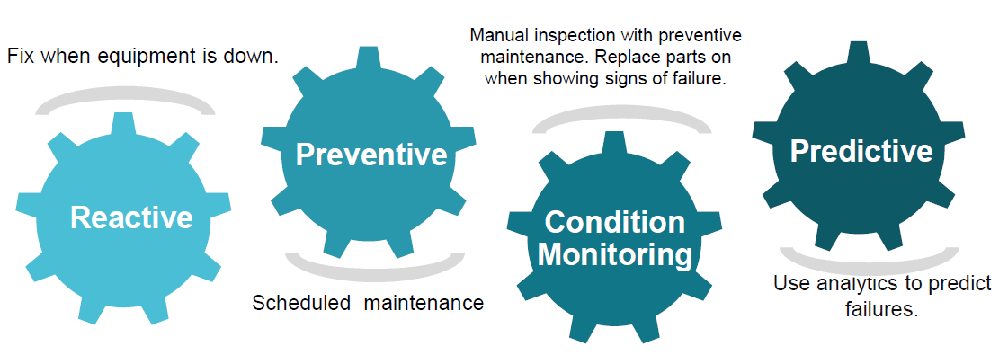

## About upskill Campus (USC)

upskill Campus along with The IoT Academy and in association with Uniconverge technologies has facilitated the smooth execution of the complete internship process.

USC is a career development platform that delivers **personalized executive coaching** in a more affordable, scalable and measurable way.



Seeing need of upskilling in self paced manner along-with additional support services e.g. Internship, projects, interaction with Industry experts, Career growth Services

https://www.upskillcampus.com/

upSkill Campus aiming to upskill 1 million learners in next 5 year

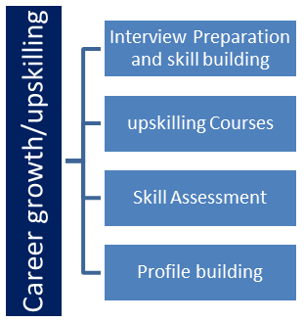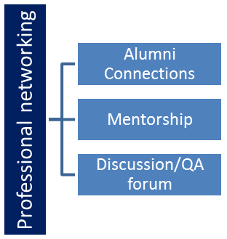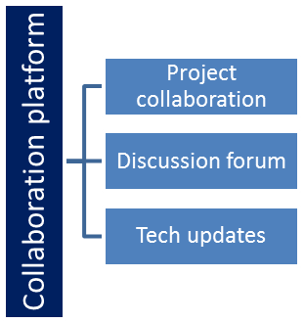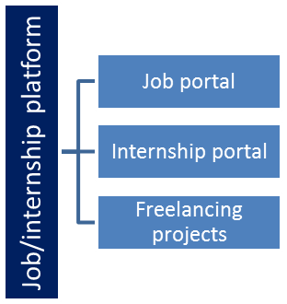

## The IoT Academy

The IoT academy is EdTech Division of UCT that is running long executive certification programs in collaboration with EICT Academy, IITK, IITR and IITG in multiple domains.

## Objectives of this Internship program

The objective for this internship program was to

 ☛ Get practical experience of working in the industry.

 ☛ To solve real world problems.

 ☛ To have improved job prospects.

 ☛ To have Improved understanding of our field and its applications.

 ☛ To have Personal growth like better communication and problem solving.

## 

## Glossary

|  |  |
| --- | --- |
| Terms | Acronym |
| CSV File | It’s called Comma Seperated File. It’s similar to an excel file. |
| Algorithm | Finite set of instructions given to the computer to perform a task. |
| MYSQL | It’s a Database used to store large amounts of data. |
| AES AND DES | Algorithms used for encryption and decryption of data in databases. |
| Data Visualization | It’s a way of representing data in the form of various graphics such as graphs, barplots etc.. |

# Problem Statement

The objective of this Python project is to develop a quiz game application that engages users by presenting them with a series of questions on various topics. The application should be able to read questions and corresponding answers from a file or database, present them to the user in a user-friendly interface, and accurately calculate and track the user's score based on their answers.

The problem statement encompasses the following key aspects:

* User Interface Design : Design an intuitive and interactive user interface that effectively displays the questions, options (if applicable), and prompts the user to input their answers. The interface should provide clear instructions and feedback to enhance the user experience.
* Question and Answer Storage : Implement a database or file system to store the quiz questions and their corresponding answers. The system should be capable of efficiently retrieving questions and associated data during the quiz, ensuring a seamless user experience.
* Question Presentation and Answer Collection : Develop a mechanism to present the questions to the user one at a time, allowing them to choose or enter their answers. The application should validate user inputs and handle different question types such as multiple-choice, fill in the blanks, or true/false.
* Scoring Algorithm : Create a scoring algorithm that accurately calculates the user's score based on their answers. Assign appropriate points for correct answers and handle penalties for incorrect responses, if applicable. The scoring system should be transparent to the user, providing feedback on their performance.
* Tracking and Final Score Calculation : Implement a mechanism to track the user's progress throughout the quiz, keeping a record of the questions answered, whether correctly or incorrectly. At the end of the quiz, calculate the user's final score based on their performance and display it to the user.

# Existing and Proposed solution

**Existing Prototype:**

While numerous Quiz Game applications are available, the majority of them are static. After completing a quiz, they only display your score temporarily, as refreshing the page erases all data. Consequently, scores are not saved, and there is no opportunity to compare performance with others.

**Proposed Prototype:**

The prototype I have proposed is dynamic and incorporates several interactive features. It securely stores user data such as their name and score in a CSV file, ensuring that the information remains intact even after refreshing the page. Furthermore, the application utilizes data visualization techniques to present the user's data in an engaging and interactive manner. The leaderboard, in particular, has been designed to be visually appealing, allowing users to compare their performance with others.

In addition, the game includes a feedback system that provides immediate notifications to users when they answer incorrectly. They receive an "Incorrect" message, along with the display of the correct answer, enabling them to learn from their mistakes and fostering a sense of competition.

## Code submission (Github link)

Github Link: https://github.com/KokkantiDivya/UpSkill_Campus

## Report submission (Github link)

Github Link: https://github.com/KokkantiDivya/UpSkill_Campus

# Proposed Design/ Model

## Interface

These are the pictures of my project interface

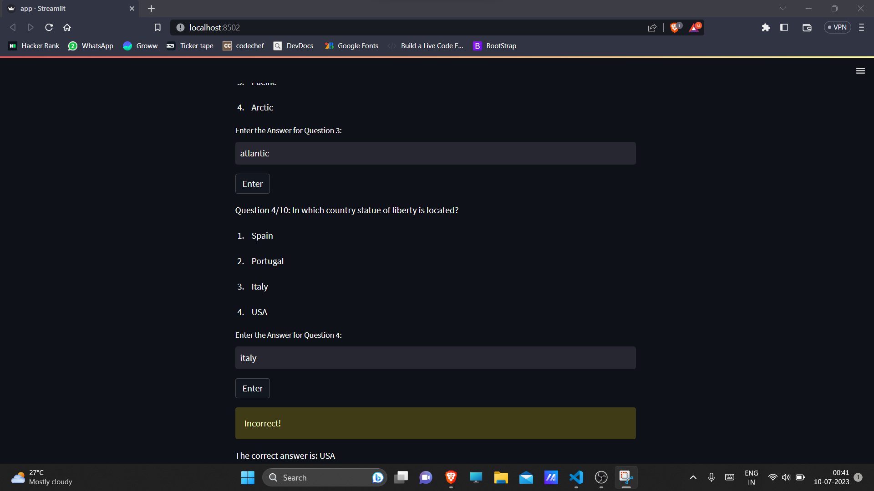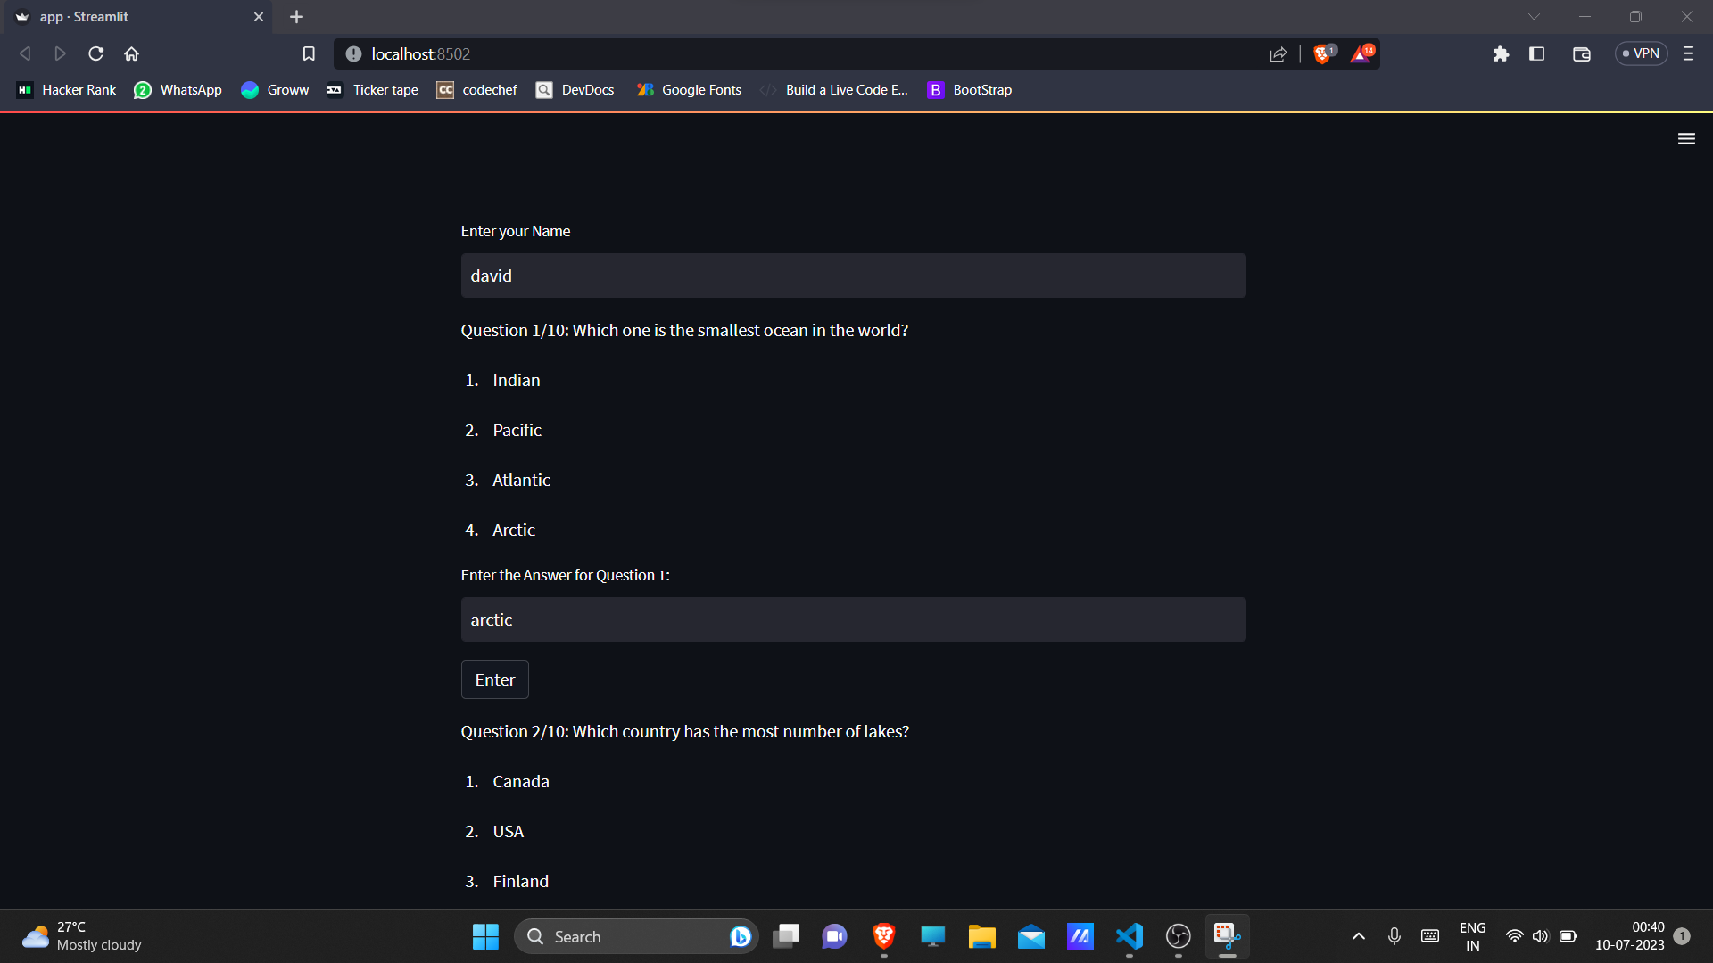

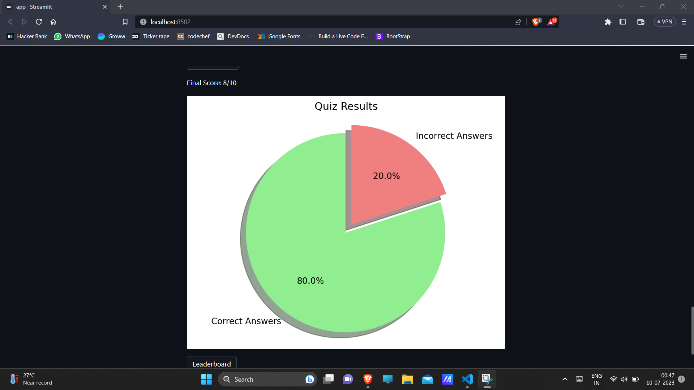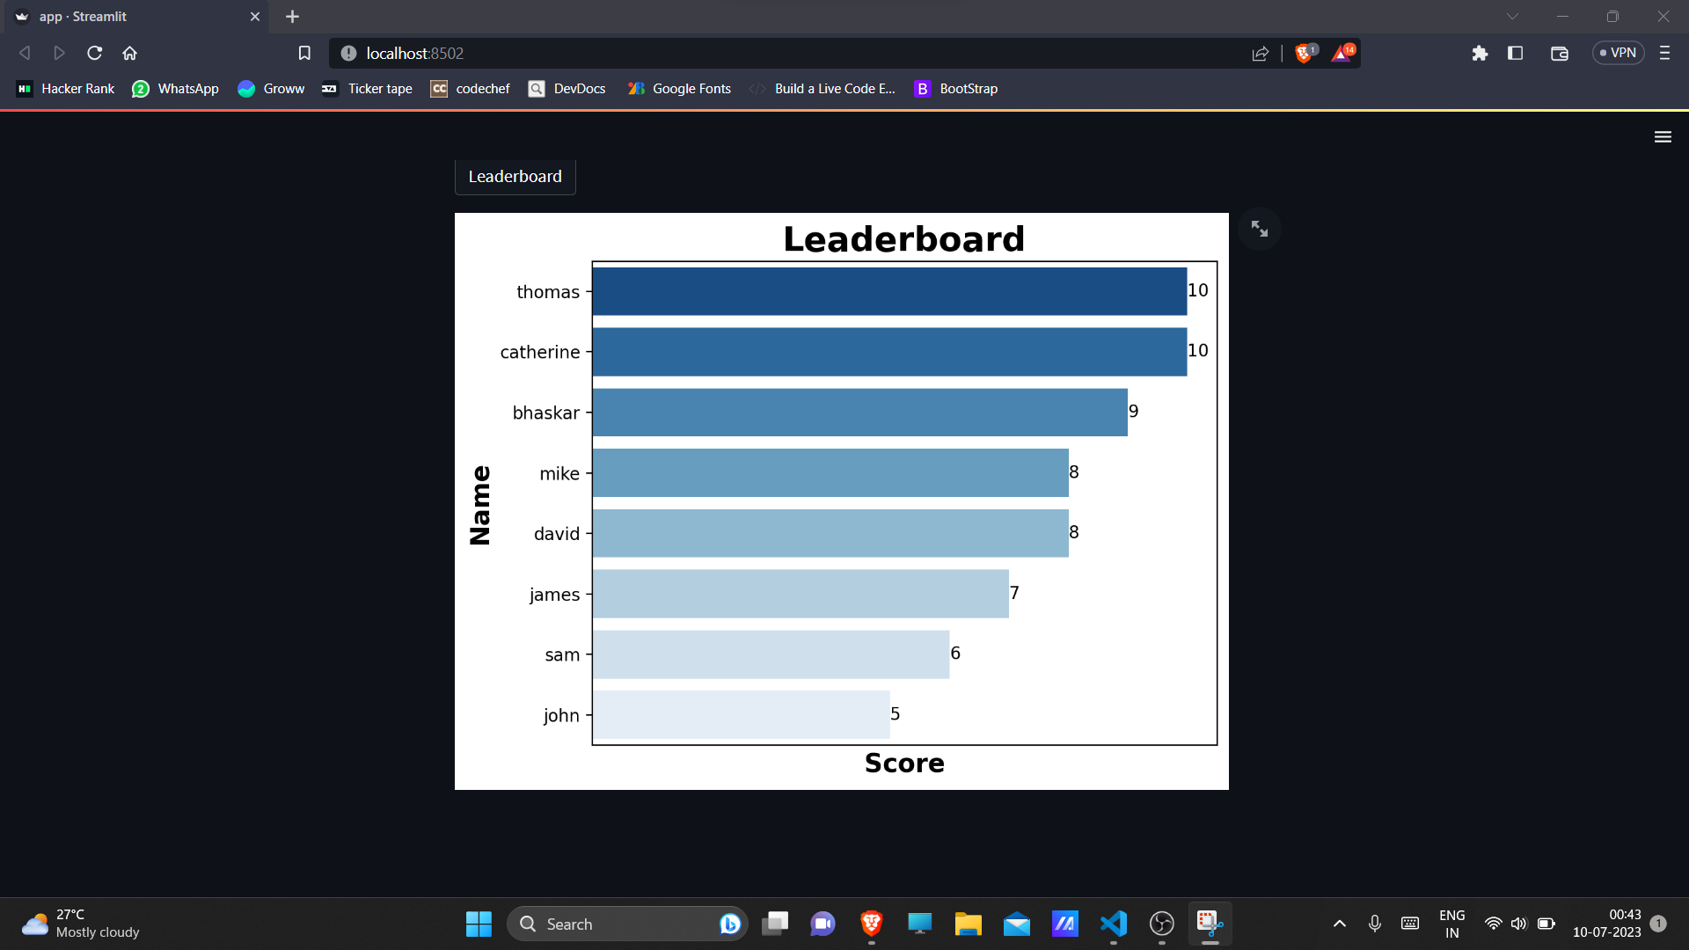

Click the below link to view the Project in Video Format

[Project Output.mkv](https://drive.google.com/file/d/1JIUOgp5XRplwhyH4CchqhVHbnDL2I_N5/view?usp=drive_link)

# Performance Test

Here are some constraints of my project :

1. **Scalability :**

The code does not currently handle a large number of questions or participants efficiently. As the number of questions or participants increases, the code may experience performance issues or slowdowns.

1. **Security :**

The code does not incorporate any form of user authentication or authorization. Therefore, it is assumed that all participants are trustworthy and can provide accurate names and scores.

1. **Managing Dependencies :**

The code relies on external libraries such as pandas, matplotlib, seaborn, and Streamlit. If proper versions of dependencies are not installed it could cause compatibility issues.

Here are some ways to tackle the constraints :

1. Optimizing the code with more scalable approaches.
2. Implementing security authentication to make sure participants provide accurate names.
3. Updating and managing the dependencies time to time to ensure that there are no compatibility issues.

# My learnings

There are a lot of things I've learned in this Internship,

Before this Internship, I used to code in Python at a beginner level because I was not aware of industrial projects, but due to the projects I've done in this Internship now I'm able to code in Python at an intermediate level and make real-world applications.

Database connectivity: Due to this Industrial project I've learned to connect MYSQL Database using Python to store the data. I've even learned AES and DES algorithms in MYSQL which are used to Encrypt and Decrypt sensitive information like passwords.

CSV Files: I've also learned to work with CSV files like reading the data from CSV files and displaying it to the users and writing the data into CSV files entered by the users.

Data Visualization: It is one of the most important skills to become a Data Analyst or Data Scientist. I've used this in my project in order to display users performance and leaderboard.

Apart from technical skills I've also improved my Report writing skills because of weekly reports.

# Future work scope

These are the ideas that I wanted to do but couldn't due to time constraints:

Instead of displaying the same questions to the same user, I want to load more questions and randomly pick ten questions from that question data set. This makes the game more fun to play and users will play it multiple times.

Use machine learning algorithms to analyze and classify questions based on their difficulty level. This can involve training a model on a labeled dataset where questions are categorized by difficulty. The model can then predict the difficulty of new questions, allowing you to dynamically adjust the quiz difficulty based on the user's performance.

Use machine learning models to predict a user's performance on specific quiz topics or difficulty levels. By analyzing various factors such as past performance, time taken to answer, and other user-specific attributes, the model can provide insights into how well a user might perform on particular quizzes.

Develop an adaptive learning system that adjusts the quiz difficulty dynamically based on the user's performance. Machine learning algorithms can analyze the user's past answers and adjust the subsequent questions' difficulty to match their skill level. This personalized approach ensures an optimal learning experience for each user.